**// STRING BASED TASK – 7 //**

Q1. Replace a character at a specific index in a

String in Java

// SOURCE CODE

import java.util.Scanner;

public class ReplaceCharacter {

public static void main(String[] args) {

Scanner sc = new Scanner(System.in);

String input = sc.nextLine();

int index = sc.nextInt();

char replacement = sc.next().charAt(0);

if (index >= 0 && index < input.length()) {

String result = input.substring(0, index) + replacement + input.substring(index + 1);

System.out.println(result);

} else {

System.out.println("Invalid index");

}

}

}

// OUTPUT

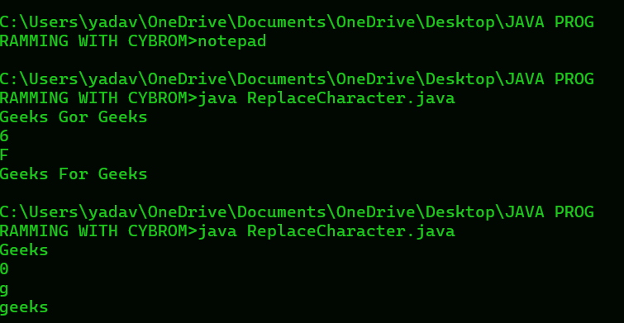

Q2. Remove Leading Zeros From String in Java?

Example:

Input : 00000123569

Output: 123569

Input: 000012356090

Output: 12356090

// SOURCE CODE

import java.util.Scanner;

public class RemoveLeadingZeros {

public static void main(String[] args) {

Scanner sc = new Scanner(System.in);

String input = sc.nextLine();

String result = input.replaceFirst("^0+", "");

System.out.println(result);

}

}

// OUTPUT

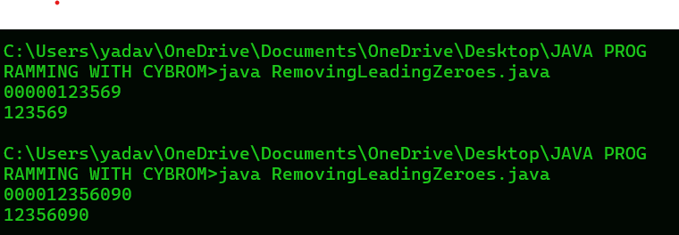

Q4. Sort a String in Java

Input string : &quot;axbycz&quot;

Output string : &quot;abcxyz&quot;

Input: str = “GeeksForGeeks”

Output: No

Explanation: The given string does not contain all the letters from a to z

(ignoring case).

import java.util.Scanner;

import java.util.Arrays;

public class SortAndCheckString {

public static void main(String[] args) {

Scanner sc = new Scanner(System.in);

String input = sc.nextLine();

// Sort the string

char[] charArray = input.toCharArray();

Arrays.sort(charArray);

String sortedString = new String(charArray);

System.out.println(sortedString);

// Check if the string contains all letters from 'a' to 'z'

input = input.toLowerCase();

boolean containsAll = true;

for (char c = 'a'; c <= 'z'; c++) {

if (!input.contains(String.valueOf(c))) {

containsAll = false;

break;

}

}

System.out.println(containsAll ? "Yes" : "No");

}

}

// OUTPUT

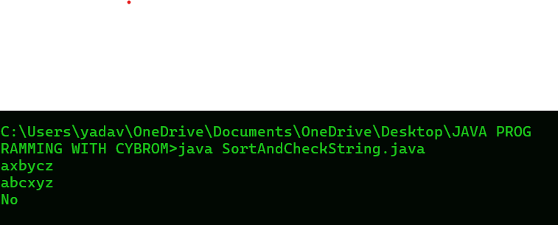

Q5. Check if a given string is Pangram in Java?

A string is a pangram string if it contains all the character of

the alphabets ignoring the case of the alphabets.

import java.util.Scanner;

class Pangram1{

public static void main(String args[ ] ){

Scanner sc =new Scanner(System.in);

System.out.print("ENTER ANY STRING: ");

String s = sc.nextLine();

boolean alphaList [ ] = new boolean[26];

int index = 0;

int res = 1;

for(int i = 0; i < s.length(); i++){

if ( s.charAt(i) >= 'A' && s.charAt(i) <= 'Z'){

index = s.charAt(i) - 'A';

}

else if ( s.charAt(i) >= 'a' && s.charAt(i) <= 'z'){

index = s.charAt(i) - 'a';

}

alphaList[index] = true;

}

for ( int i = 0; i <= 25; i++){

if ( alphaList[i] == false)

res = 0;

}

if ( res == 1){

System.out.print("YES");

}

else{

System.out.print("NO");

}

}

}

// OUTPUT

